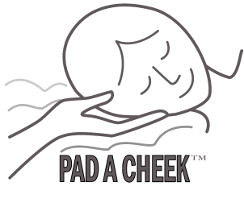
PAD A CHEEK
®
Mask Liner
AirFit F30 Full Face

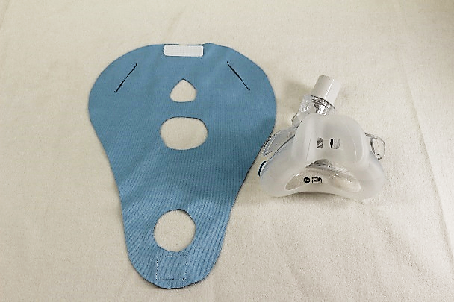
Make certain no exhalation vents are covered with the Mask Liner

1. Lay the PAD A CHEEK Mask Liner flat with the teardrop hole at the top and the white Velcro at the top showing.
This is IMPORTANT for the installation of the mask liner.

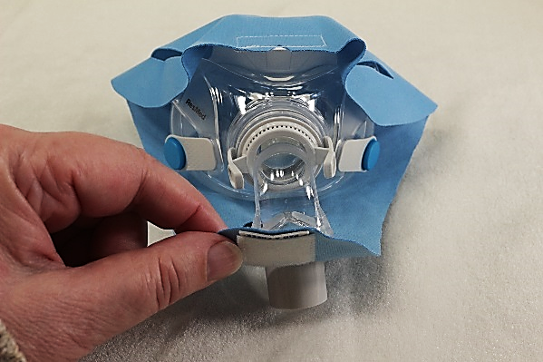
2. Place the mask, (without headgear) on the mask liner. Place the mouth opening down on top of the center hole in the liner. The hose connector should be right at the round hole at the bottom of the liner.

3. Pull the mask liner up over the top of the mask like in the second photo.

4. Lift the bottom of the mask liner up and put the round
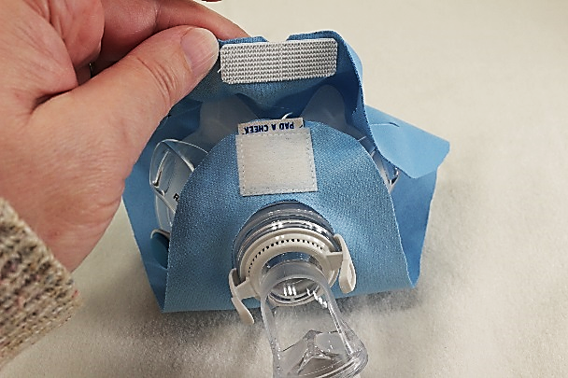
hole over the hose connection and over both the cream
colored tabs as in the third photo. See the square Velcro.

5. Push the headgear connectors through the slits as shown.

6. Re-attach the fabric headgear like in photo below.

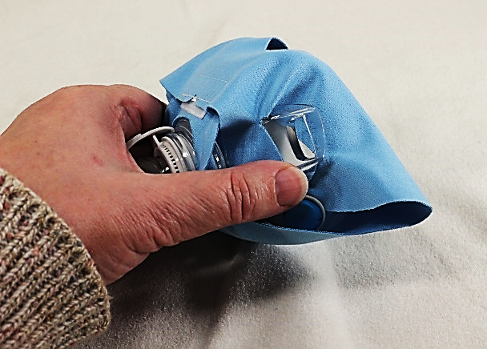
7. When wearing the mask liner, tug on the sides of the mask liner to remove wrinkles between the liner and the cushion of the mask, this will help prevent leaks. You can always trim any of the holes larger if necessary.
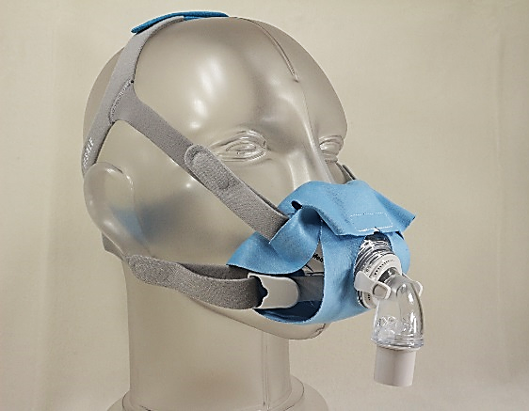

The PAD A CHEEK® Mask Liner is made from polyester micro fiber and should be hand washed with warm soapy water weekly and laid flat to air dry. If you have any questions, please contact us.

PAD A CHEEK® 434-985-4003
157 Sunset Drive, Stanardsville, VA 22973
email admin@padacheek.com web site www.padacheek.com Designed and Sewn in the USA

